Geometry Name___________________________

7.0 Dilations Practice

1. Triangle *XYZ* is graphed below. Determine the coordinates of the image X’Y’Z’after a dilation using a scale factor of two. Draw and label triangle X’Y’Z’



Transformation Rule: (x, y) → ( , )

*X*  🡪 *X’* _________

*Y* 🡪 *Y’* _________

*Z* 🡪 *Z’*__________

2. Quadrilateral *A’B’C’D’* is a dilation of quadrilateral *ABCD.*



1. Find the scale factor.
2. Write the transformation rule.
3. Is this dilation as an enlargement or a reduction?

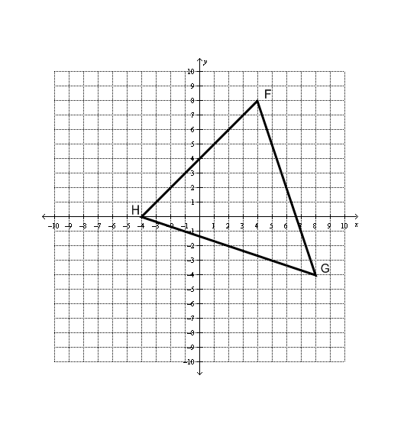

3. On the grid below, draw the image of  after a dilation with a scale factor of .

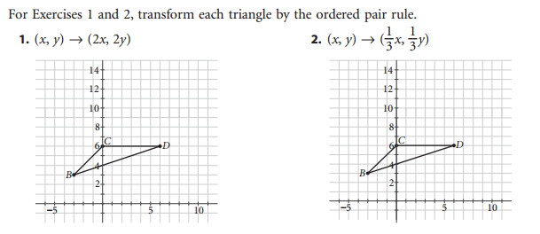

4.

5.

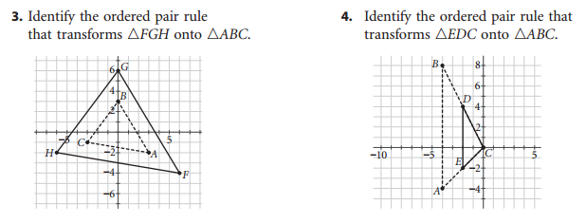

6.

7.

8. Triangle *PQR* has coordinates P(2, 4), Q(-2, 4), R(0, -6).

1. Write the coordinates of the vertices of the image of a triangle after a dilation of 1.5.
2. Is this image an enlargement or reduction of the pre-image?