**Chapter 9 Review Name________________________________________**

**Math 3313 Date ____________________________ Period ______**

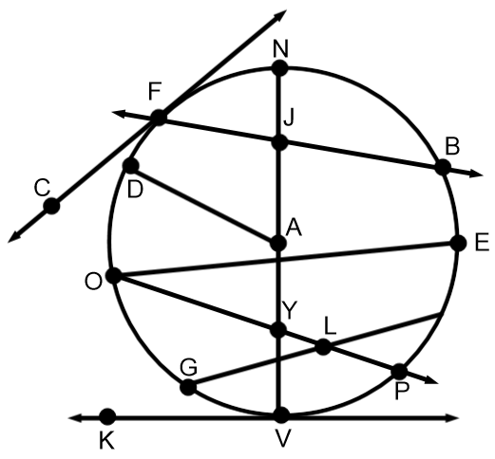**Use the figure of Circle A at right to answer #1 - # 9. If a line appears tangent, assume it is tangent.**

**Be as specific as possible.**

**1. Name two radii:_______________________________**

**2. Name two chords:_______________________________**

**3. Name a secant:_______________________________**

**4. Name two tangent:_______________________________**

**5. Name two Central angles:_________________________**

**6. Name a diameter:________________________________**

**7. F is a _________________________**

**8. is an ____________________________________**

**9. Name a right angle:_______________________________**

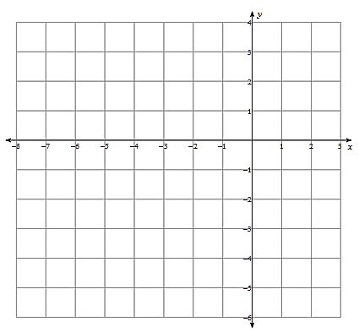**Given the equation of a circle, find the center, and radius of the circle. Then graph the circle.**

**10. ${\left(x+3\right)}^{2}+{\left(y+2\right)}^{2}=9$**

Center:______________

Radius:______________

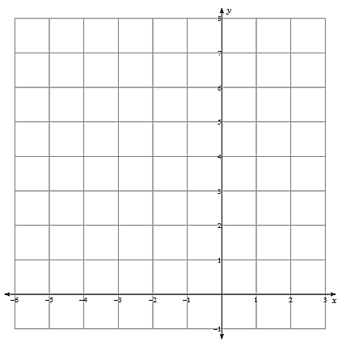

**10. ${\left(x+2\right)}^{2}+{\left(y-4\right)}^{2}=4$**

Center:______________

Radius:______________

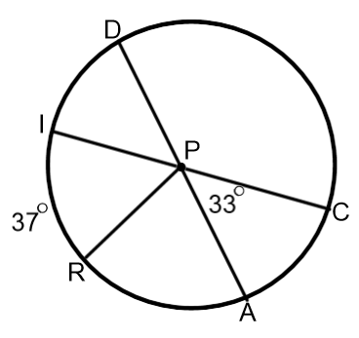**Use the figure of circle P at right to find the missing arc or angle measures.**

**12. $m\hat{AC}=$____________ 13. $m\hat{RA}=$

____________**

**14. $m∠DPI=$____________ 15. $m∠CPD=$

____________**

**16. $m\hat{CDR}=$__________ 17. $m\hat{AI}=$

__________**

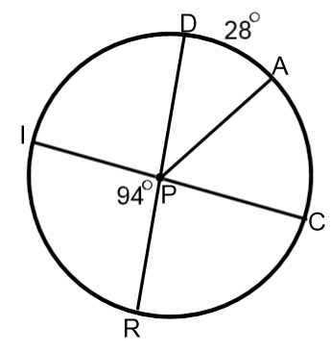**Use the figure of circle P at right to find the missing arc or angle measures.**

**18. $m\hat{RC}=$____________ 19. $m\hat{ID}=$

____________**

**20. $m∠CPR=$____________ 21. $m∠APR=$

____________**

**22. $m\hat{IA}=$__________ 23. $m\hat{RIA}=$

__________**

**24. Write equation of a circle with center (-8, 9) and radius 7.**

**25. Write equation of a circle with center (24, -13) and radius 13.**

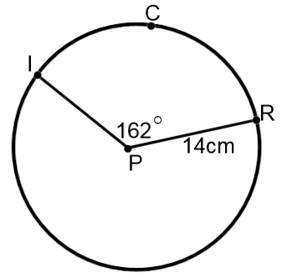**For 26-27, find the arc length of the following.**

**26. Exact arc length of ICR:____________**

**Approximate arc length of ICR:___________**

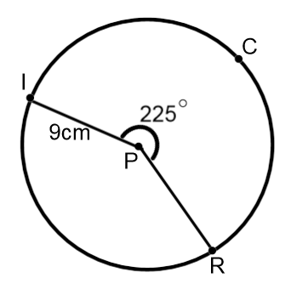

**27. Exact arc length of ICR:____________**

**Approximate arc length ICR:___________**

**Solve for the value of x.**

**28. 29.**

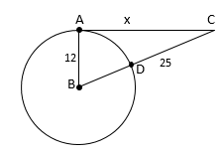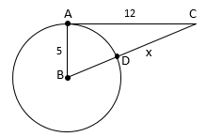

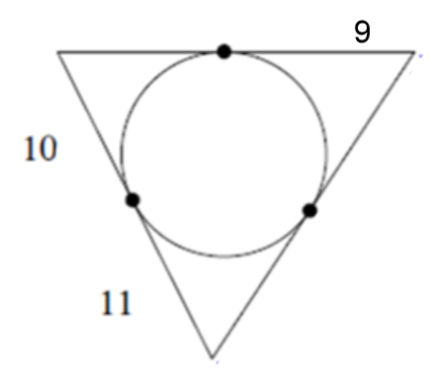**30. Find the perimeter of quadrilateral ABCD. 31. Find the perimeter of the triangle.**

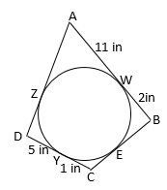

**Find the value of the following variables.**

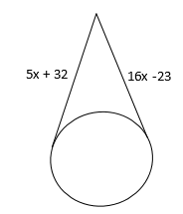

**32. 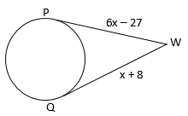 33.**

**34. 35.**

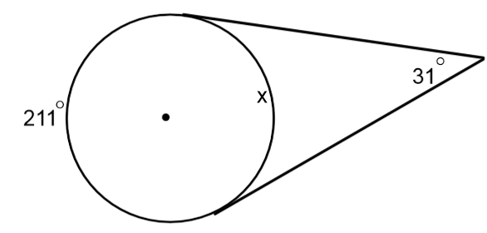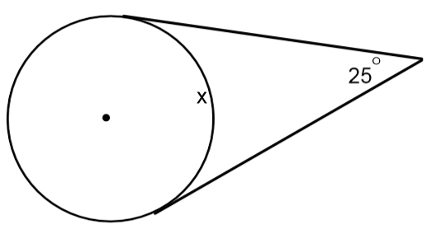

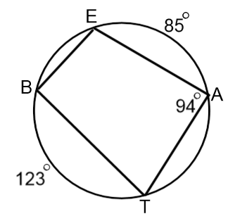**Find the following missing measures.**

**36. =________**

**37. $m\hat{AT}=$

___________**

**38. $m\hat{BE}=$

___________**

**36. =________**

**39. =________**

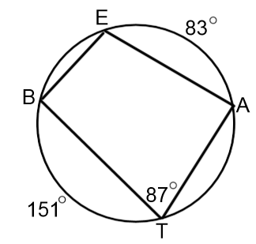**Find the following missing measures.**

**36. =________**

**37. $m\hat{AT}=$

___________**

**38. $m\hat{BE}=$

___________**

**36. =________**

**39. =________**

**Find the value of the following variables.**

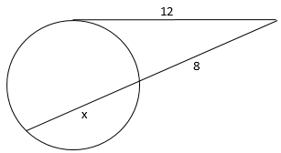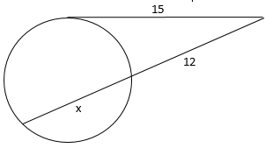

**40. 41.**

**Find the value of the following variables.**

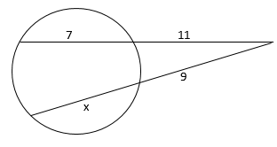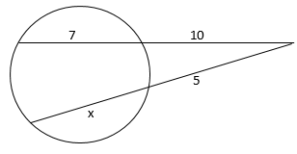

**42. 43.**

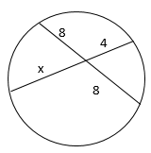

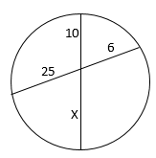**44. 45.**

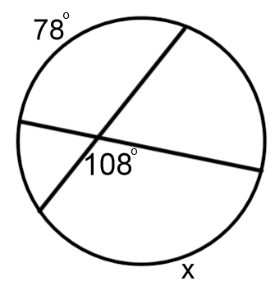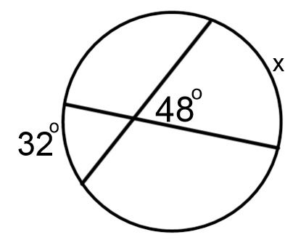

**46. 47.**

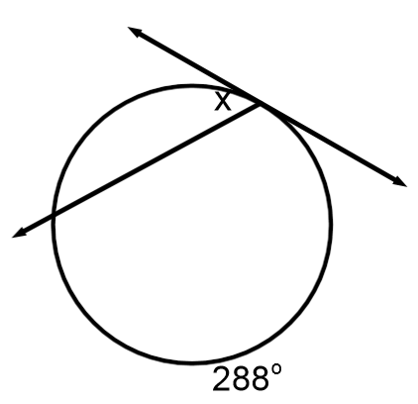**Find the value of the following variables.**

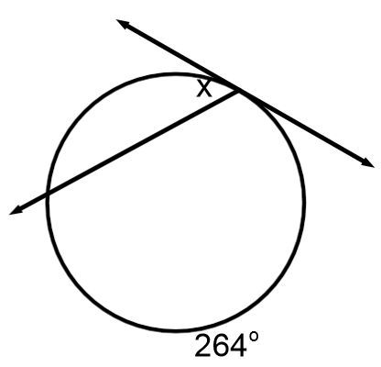

**48. 49.**

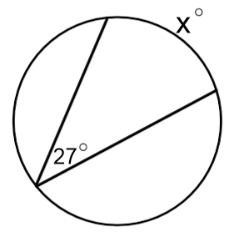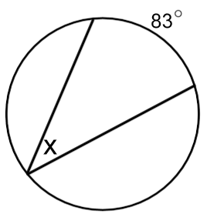**50. 51.**