**7.1 Similar Polygons Homework Name_________________________________________**

1. Given ABCDE ~ FGHIJ.

A

B

C

D

E

20

9

12

6

8

F

G

H

I

J

10

4.5

6

3

4

List the corresponding sides in the form of ratios. The first has been done for you.

$\frac{AB}{FG}$

List the congruent angles. The first has been done for you.

$$∠A≅∠F$$

Find the scale factor of ABCDE to FGHIJ.

**Are the polygons below similar? Explain why or why not. If so, what is the scale factor from the larger to smaller polygon?**

16

16

16

52

14

20

18

26

30

27

39

78

21

2. 3.

10

10

10

Similar / Not Similar (circle one)

Reason:_______________________________________________

Scale factor of larger to smaller: _____________

Similar / Not Similar (circle one)

Reason:_______________________________________________

Scale factor of larger to smaller: _____________

**For #4 and 5, use the similarity statement to find the missing information.**

4. 5.

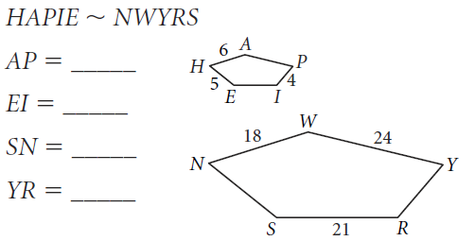

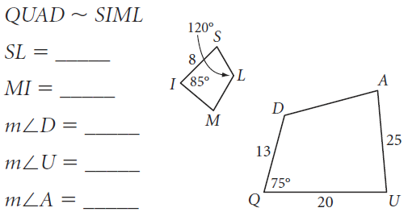

**The polygons below are similar. Solve for the missing variable(s).**

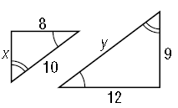6.

x = ________

y = ________

7.

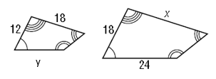

x = ________

y = ________

8. In the diagram below, ~.

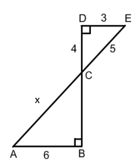

Scale Factor of ABC to EDC : ________

x = ________

9. In the diagram below, .

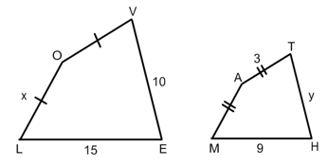

Scale Factor of LOVE to MATH: _________

x = ________

y = ________