**Chapter 11 Test Review Name: _______________________________________**

**Math 3313 – Geometry Date _________________________ Period __________**

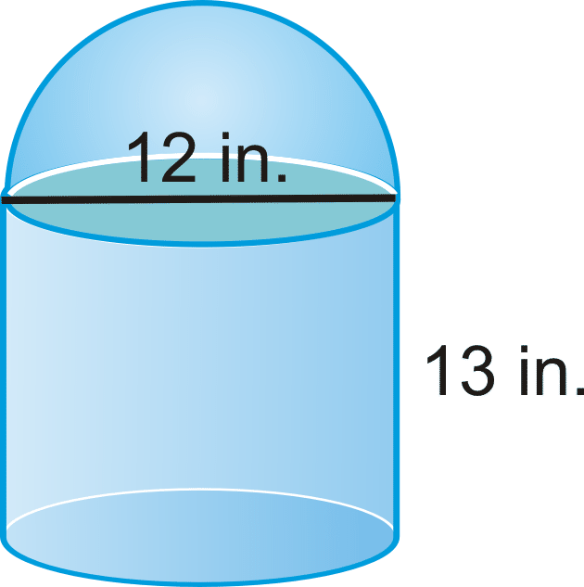1. What is the difference between finding the volume and the surface area of the composite solid?

**____________________________________________________________________________________**

**____________________________________________________________________________________**

**____________________________________________________________________________________**

2. You would like to line the inside of a drawer with shelf liner, including the sides. There is no top to the drawer. How much shelf liner will you need to cover the inside surface? Round to the nearest tenth.



**8 in**

**18.5 in**

**22.25 in**

3. You need to electroplate the following metal wedge with a thin layer of high-conducting silver. The measurements shown are in centimeters. How much silver will be needed? Round to the nearest tenth.

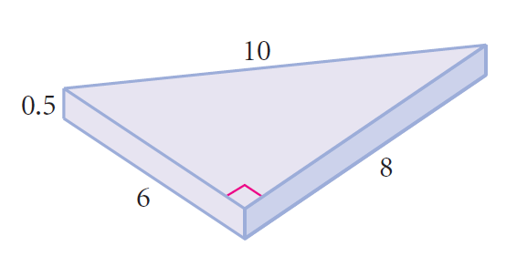

4. You would like to fill the can to the right with candy as a gift for Mother’s Day. It is 11 cm deep and has a diameter of 8 cm.

1. Before you give it as a gift, you’d like to cover the outside with colorful paper. How much paper will you need to cover the side and the bottom of the can? Do not include the top. Round to the nearest tenth.
2. What is the volume of candy that the container will hold? Round to the nearest tenth.

5. How much sheet metal is required to make a cylindrical trash can with a diameter of 2 feet and height of 4.25 feet? Round to the nearest tenth. Do not include the top. Round to the nearest tenth.

What is the volume of trash that the trash can will hold? Round to the nearest tenth.

**Find the total volume of the composite solids below. Round to the nearest tenth.**

**6. 7.**

18 ft

15 ft

16 ft

18 ft

5 ft

14 ft

**Volume of Hemisphere: __________________ Volume of Pyramid: __________________**

**Volume of Cylinder: ___________________ Volume of Prism: ___________________**

**Total Volume: _______________________ Total Volume: _______________________**

**Find the total surface area of the composite solids below. Round to the nearest tenth.**

**8. 9.**

7 m

24 m

40m

9m

53m

**Slant Height:___________________**

**Cone Lateral Area: ______________ Slant Height:___________________**

**Cylinder Lateral Area: _____________ Hemisphere Surface Area: _________________**

**Cylinder Base Area: ________________ Cone Lateral Area: ____________________**

**Total Surface Area: ________________ Total Surface Area:____________________**

**For #10-13, find the required information. Round to the nearest tenth.**

**10. 11.**

14 m

24 m

14 m

20 cm

15cm

**Slant Height: __________________ Slant Height: __________________**

**Lateral Area: __________________ Lateral Area: __________________**

**Area of Base: __________________ Area of Base: __________________**

**Surface Area: __________________ Surface Area: __________________**

**Volume: __________________ Volume: __________________**

**12. 13.**

16 in

18 in

4 m

3 m

5 m

17 m

**Lateral Area: __________________ Lateral Area: __________________**

**Area of Base: __________________ Area of Base: __________________**

**Surface Area: __________________ Surface Area: __________________**

**Volume: __________________ Volume: __________________**

**Find the surface area and volume each. Round to the nearest tenth.**

**14. 15. 16.**

7 in

22 mm

9 ft

**Surface Area: _________________ Surface Area: _________________ Surface Area: _________________**

**Volume: __________________ Volume: __________________ Volume: __________________**

**17. Indicate whether the following are examples of surface area or volume. (Circle one)**

Filling a test tube with a solution S.A. / Volume

Covering a textbook with a book cover S.A. / Volume

The amount of ice cream in a container S.A. / Volume

Painting the outside of a shed S.A. / Volume

Lining a drawer shelf with paper S.A. / Volume

The amount of tile needed to tile a bathtub surround S.A. / Volume

The amount of candy that a piñata can hold S.A. / Volume

**For each geometric solid, identify the number of faces, edges, and vertices.**

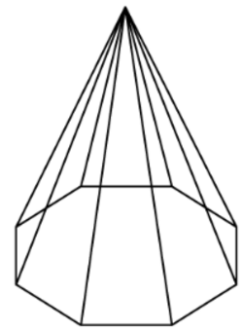

**18. 19. 20. 21.**



Faces: ___________ Faces: ___________ Faces: ___________ Faces: ___________

Edges: ___________ Edges: ___________ Edges: ___________ Edges: ___________

Vertices: _________ Vertices: _________ Vertices: _________ Vertices: _________