Algebra 2 Homework Name:__________________________________
Solving Log/Exp Equations – Mixed Practice Date: ______________ Period: ________
LOGARITHMIC FORM EXPONENTIAL FORM CHANGE OF BASE FORMULA SPECIAL BASES
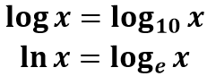
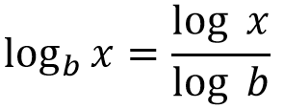
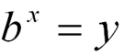
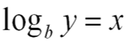

We have learned how to solve 3 different equation types:
- Equations requiring rewriting from Logarithmic Form Exponential Form
- Equations requiring rewriting from Exponential Form Logarithmic Form
  - Change of Base Formula needed
- Equations using One-to-One Property
1.) Identify the mistake each student made when solving. Then solve the equation correctly.
$$3·4^{x-5}=300$$
Brent Lily Isaac Solve correctly:
$3·4^{x}=300$ $3·4^{x}=300$ $3·4^{x}=300$ $3·4^{x}=300$
${12}^{x}=300$ $4^{x}=100$ $4^{x}=100$
$\log_{12}{300}=x$ $\log_{100}{4}=x$ $\log_{4}{100}=x$
$\frac{\log_{ }{300}}{\log_{ }{12}}=x$ $\frac{\log_{ }{4}}{\log_{ }{100}}=x$ $\frac{\log_{ }{100}}{4}=x$
$2.30=x$ $0.30=x$ $0.50=x$
_____________________ _____________________ ___________________
_____________________ _____________________ ___________________
_____________________ _____________________ ___________________

Mixed Practice - solve each equation for x. If necessary, round to the hundredths.

2.) ${3∙2}^{3x}=7500$ 3.) $5^{x+6}-100=900$

Mixed Practice - solve each equation for x. If necessary, round to the hundredths.

4.) $\log_{8}{(16x)}=3$ 5.) $\log{(x+30)}=2$

6.) ${16}^{x+9}={16}^{5x-3}$ 7.) $e^{10}=e^{20x+50}$

8.) $\ln{4x=3}$ 9.) $10\ln{(x-40)}=60$

10.) $\log_{7}\left(x+24\right)=\log_{7}{(4x)}$ 11.) ${2∙4}^{x-6}=500$

12.) Your bank account balance can be modeled by the following equation:
$$y=3500{(1.0025)}^{12t}$$
where t represents the number of years that have passed.

How many years will it for your balance to reach $17,500? Round to the nearest tenths.

13.) Your bank account balance can be modeled by the following equation:
$$y=1100e^{0.05t}$$
where t represents the number of years that have passed.

How many years will it for your balance to reach $5,500? Round to the nearest tenths.

